**FRICTION IN PIPES**

Apparatus used:

Pipes having different diameter connected to a differential manometer, a collecting tank, stopwatch, scale

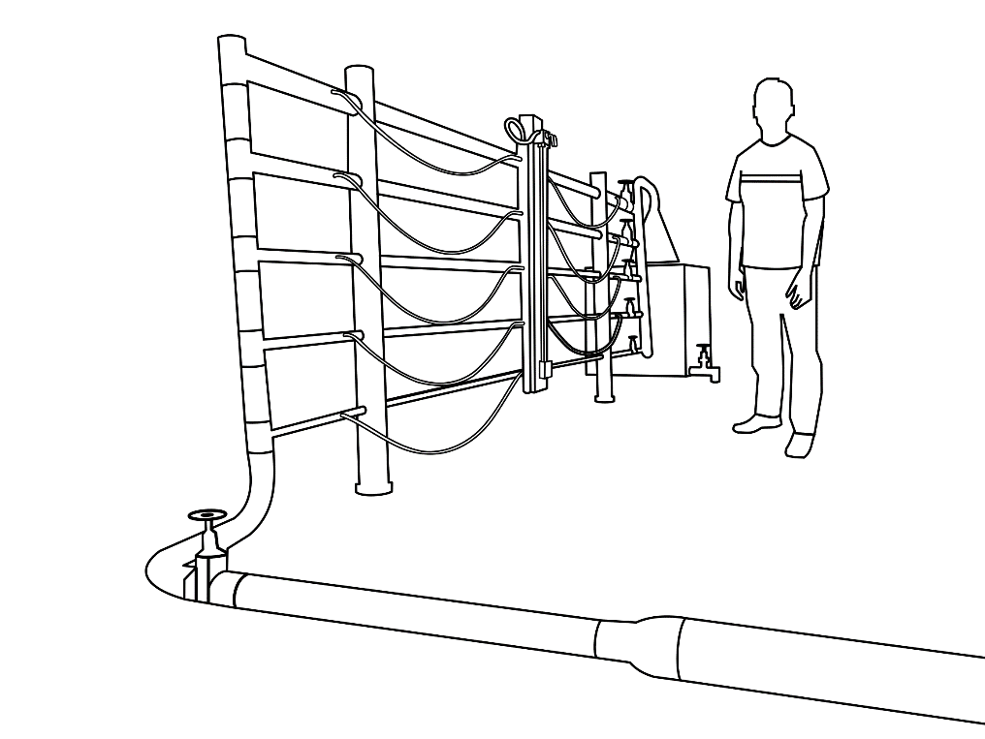

**STEP:➊**A pipe of the required diameter is selected from the setup.

Diameter of the pipe=____________

Length of the pipe=______________

**STEP:➋**Except for the selected diameter pipe, the rest of the pipes are closed.

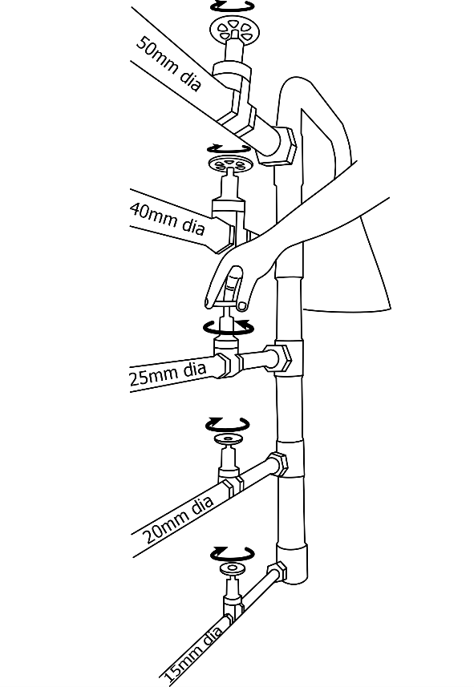

**STEP:➌** Themain inlet valve is opened to allow water to flow through the selected diameter pipe. Open the pipe valve, and change the knot of manometer from isolate position to air-vent position to remove the air inside the pipe.

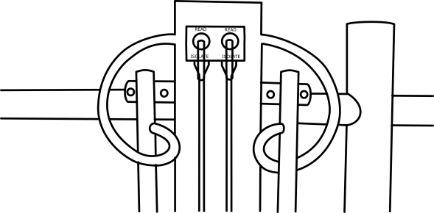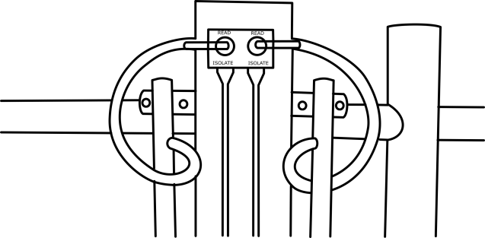

Isolate position air-vent position

**STEP:➍** Change the knot toreadposition when the steady flow is reached inside the pipe.Turn on the exit valve of the collecting tank to allow water flowing inside the pipe to continuously flow out.

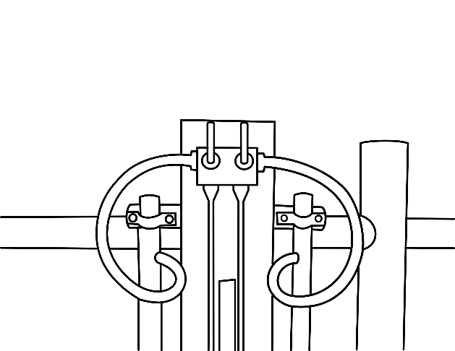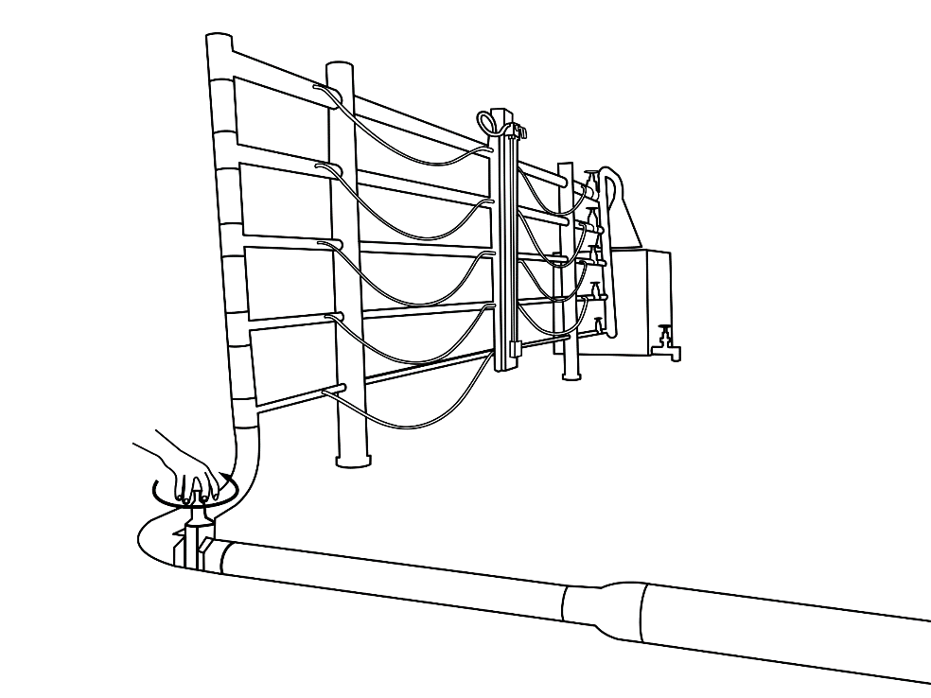

**STEP:➎**Note down the manometer reading

**STEP:➏**The exit valve of the collecting tank is closed and time taken for the tank water to rise by 10cm is noted.

**STEP:➐**Observations and Calculations:

Length of the tank=_______

Breadth of the tank=__________

Area of collecting tank=__________cm3

Qact=______________cm3/sec

Velocity=_________________cm/sec

F=

From the data obtained by the above experiment graph of log v/s log v is plotted and the coefficient of friction is obtained graphically.